**Lab 3**

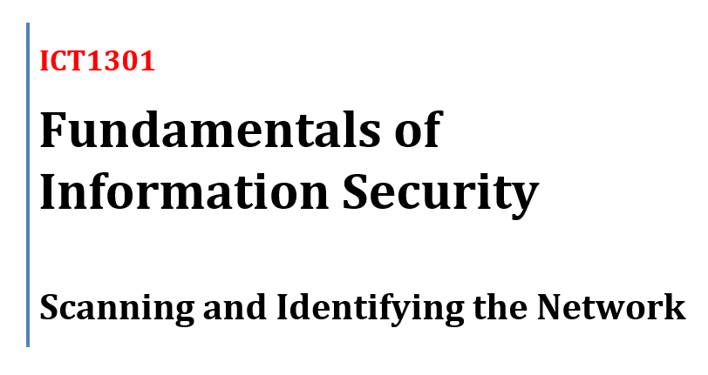

# Task A: Identify Local Network Configuration

### On Kali Linux

Step 1–2:  
Open Terminal (as root)

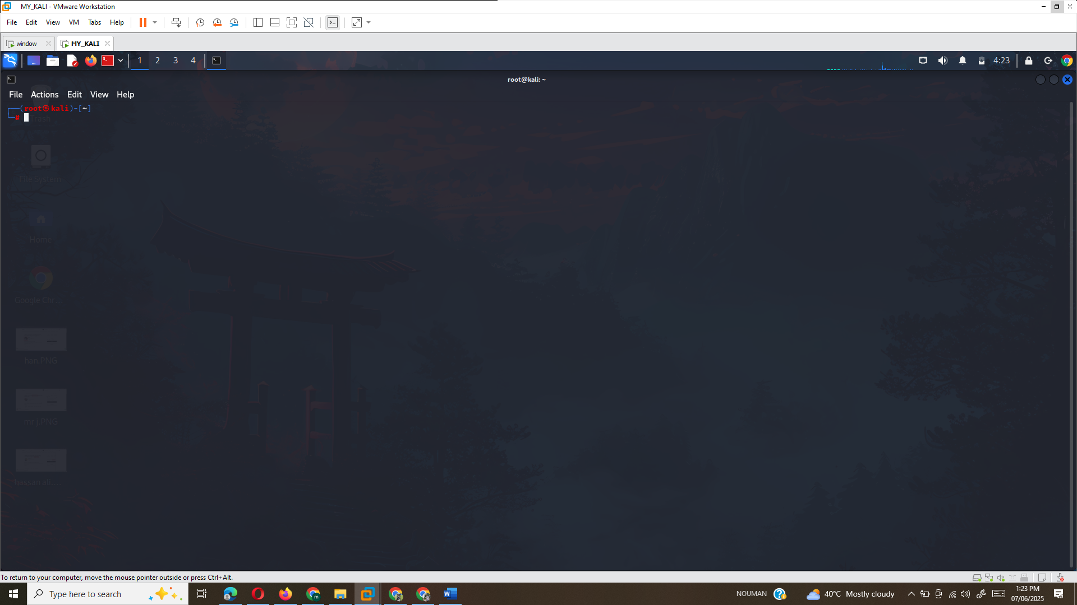

## Step 3:

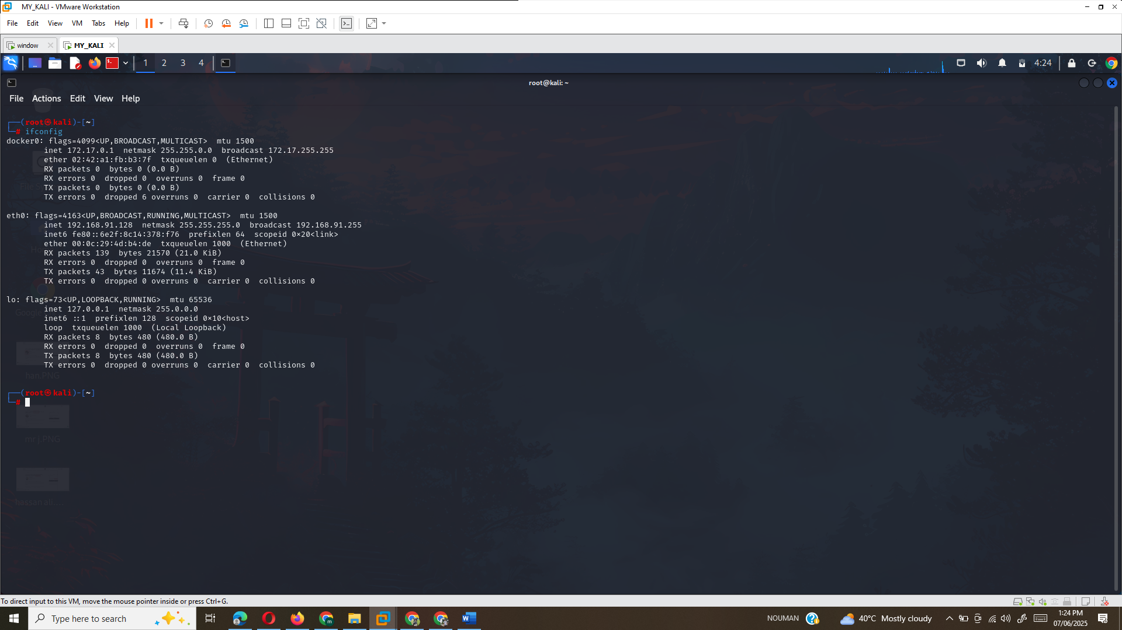

### Look for eth0 IP address → should show 192.168.91.128

## Step 4:

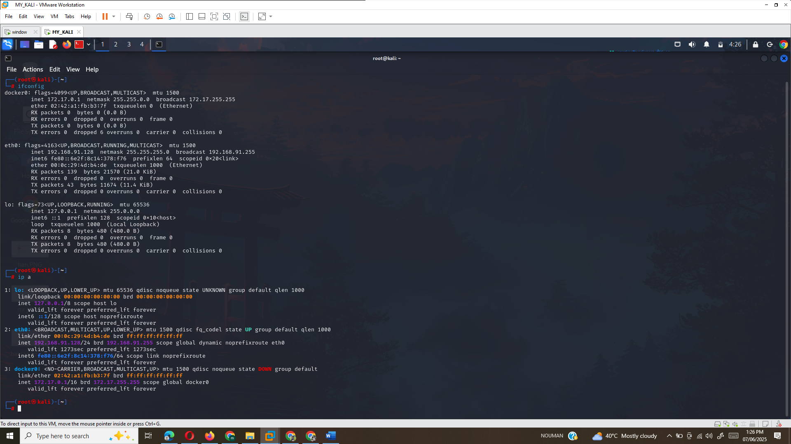

Step 5:  
Answer: 192.168.91.128

## Step 6:

## ip route show

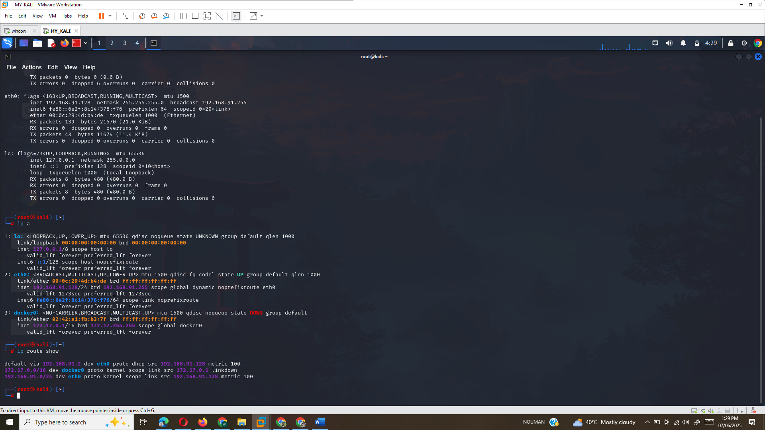

## Step 7:

Look for: default via 192.168.91.2 dev eth0 →  
Answer: 192.168.91.2

## Step 8:

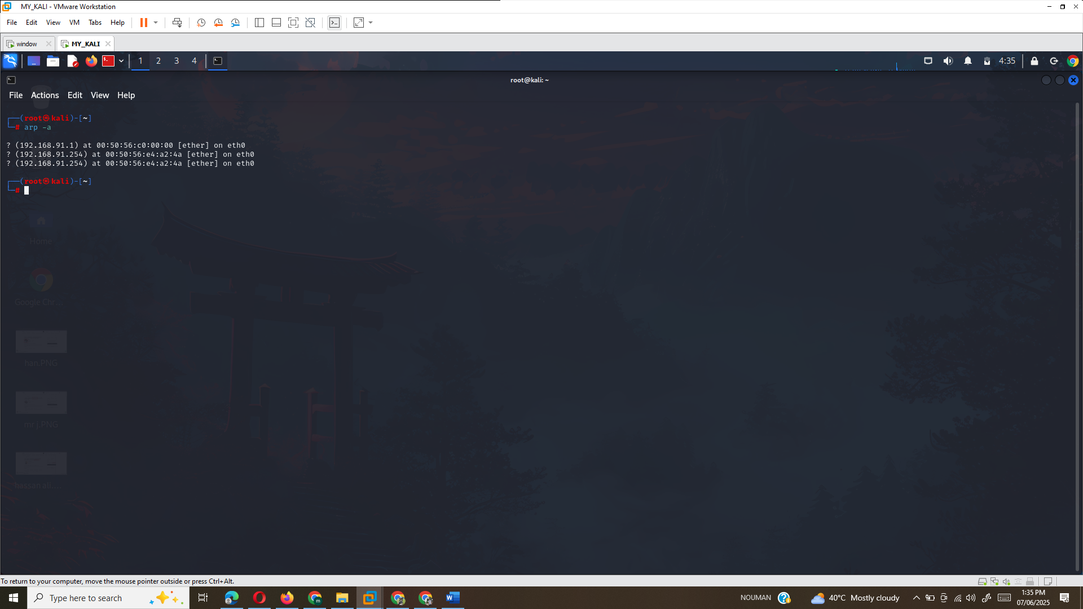

## Step 9:

The IP address for the other device in the network is **192.168.91.254**.

Step 10:

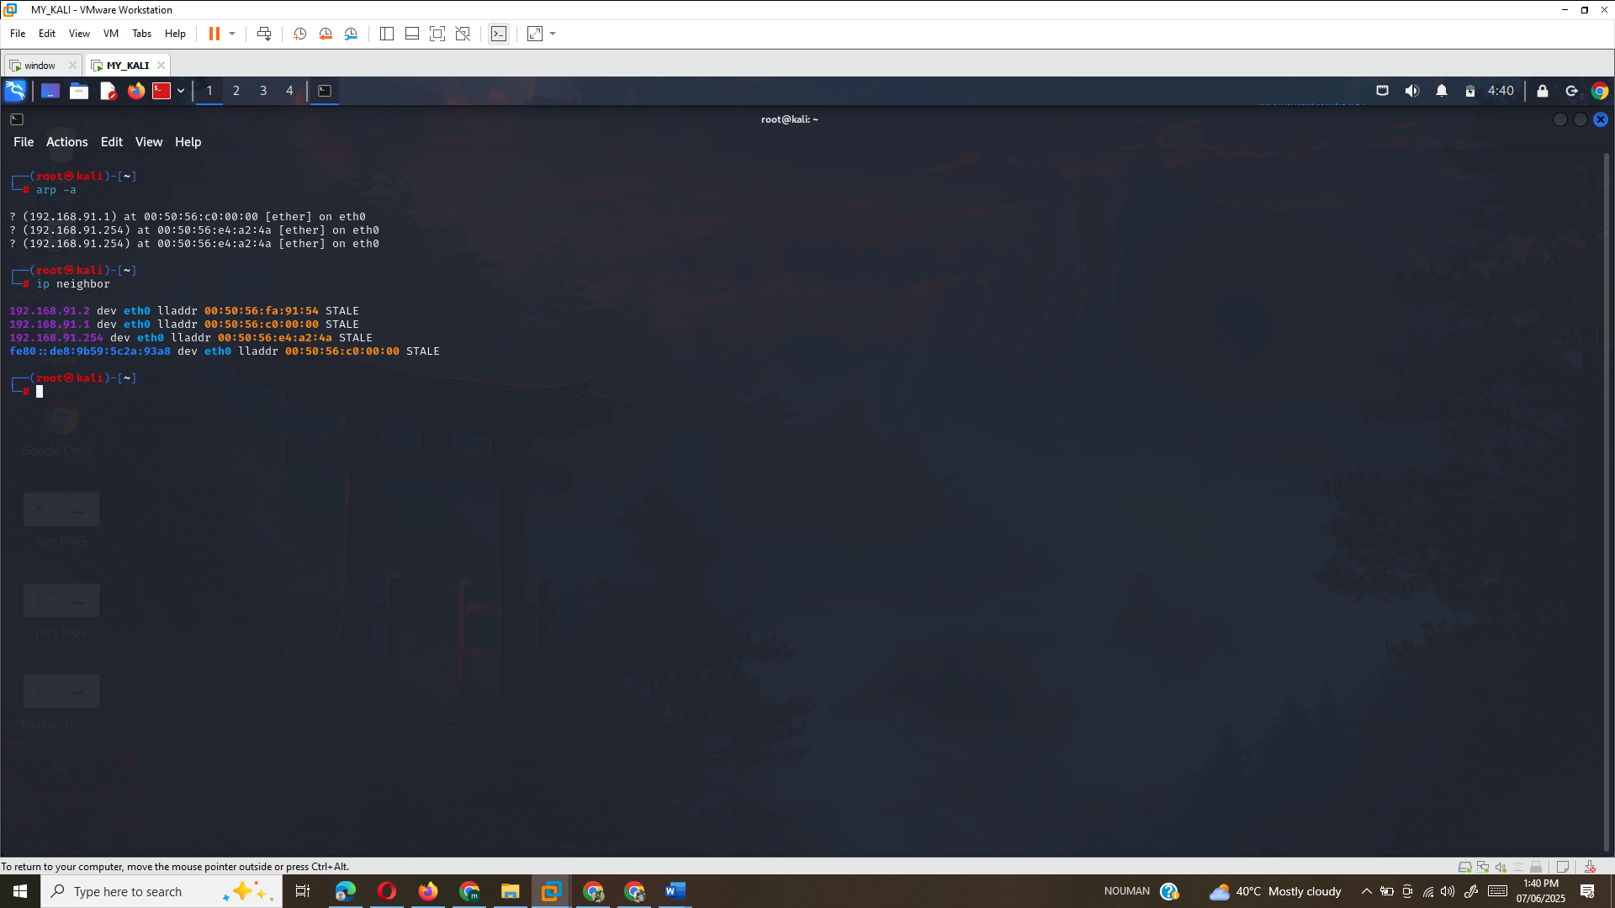

## Step 11:

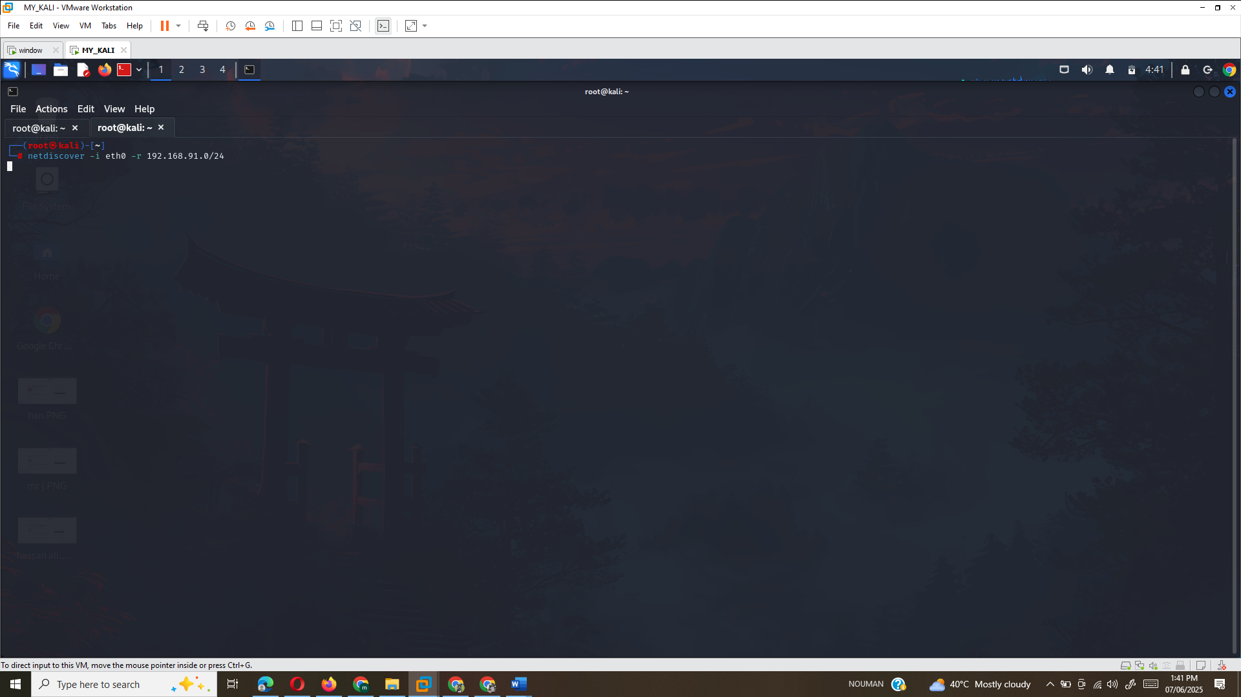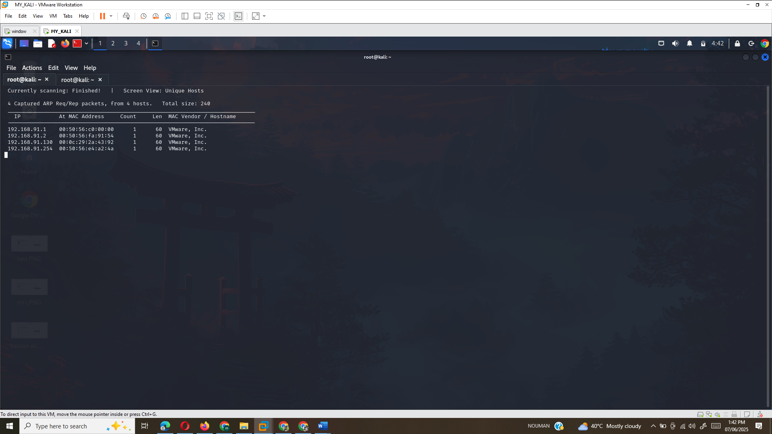

## Step 12:

Based on the output from **netdiscover** in our screenshot, the hosts discovered are:

* **192.168.91.1**
* **192.168.91.254**
* **192.168.91.130** (not listed but assumed to be part of the network)

**Answer for Step 12:**

The number of hosts discovered by **netdiscover** is **4**.

## Step 13:

**Press q to quit Netdiscover**

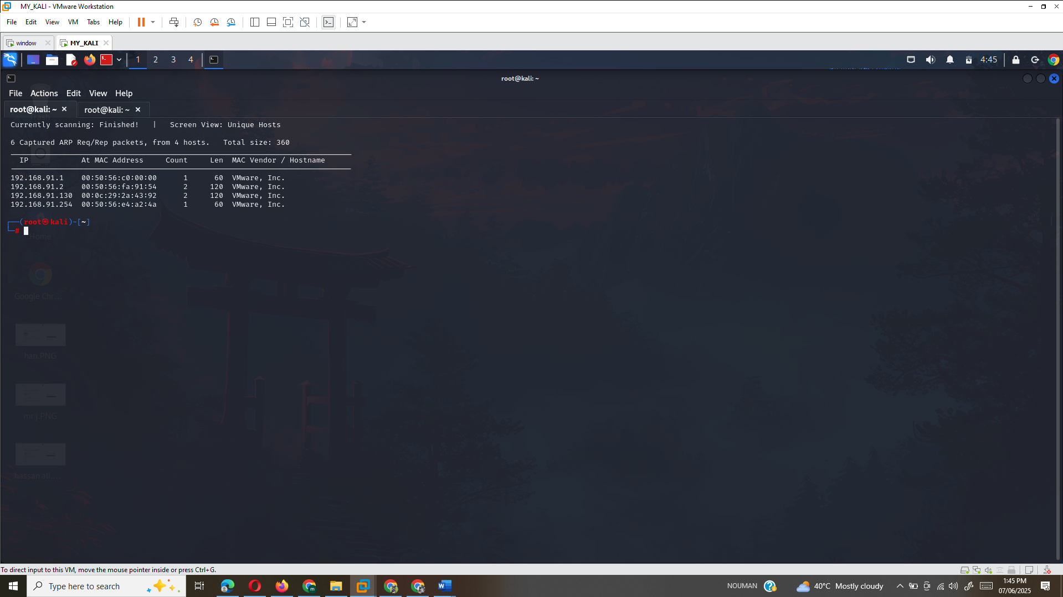

**On Windows 10 VM**

Step 14–15:  
Login → Run Command Prompt as Administrator

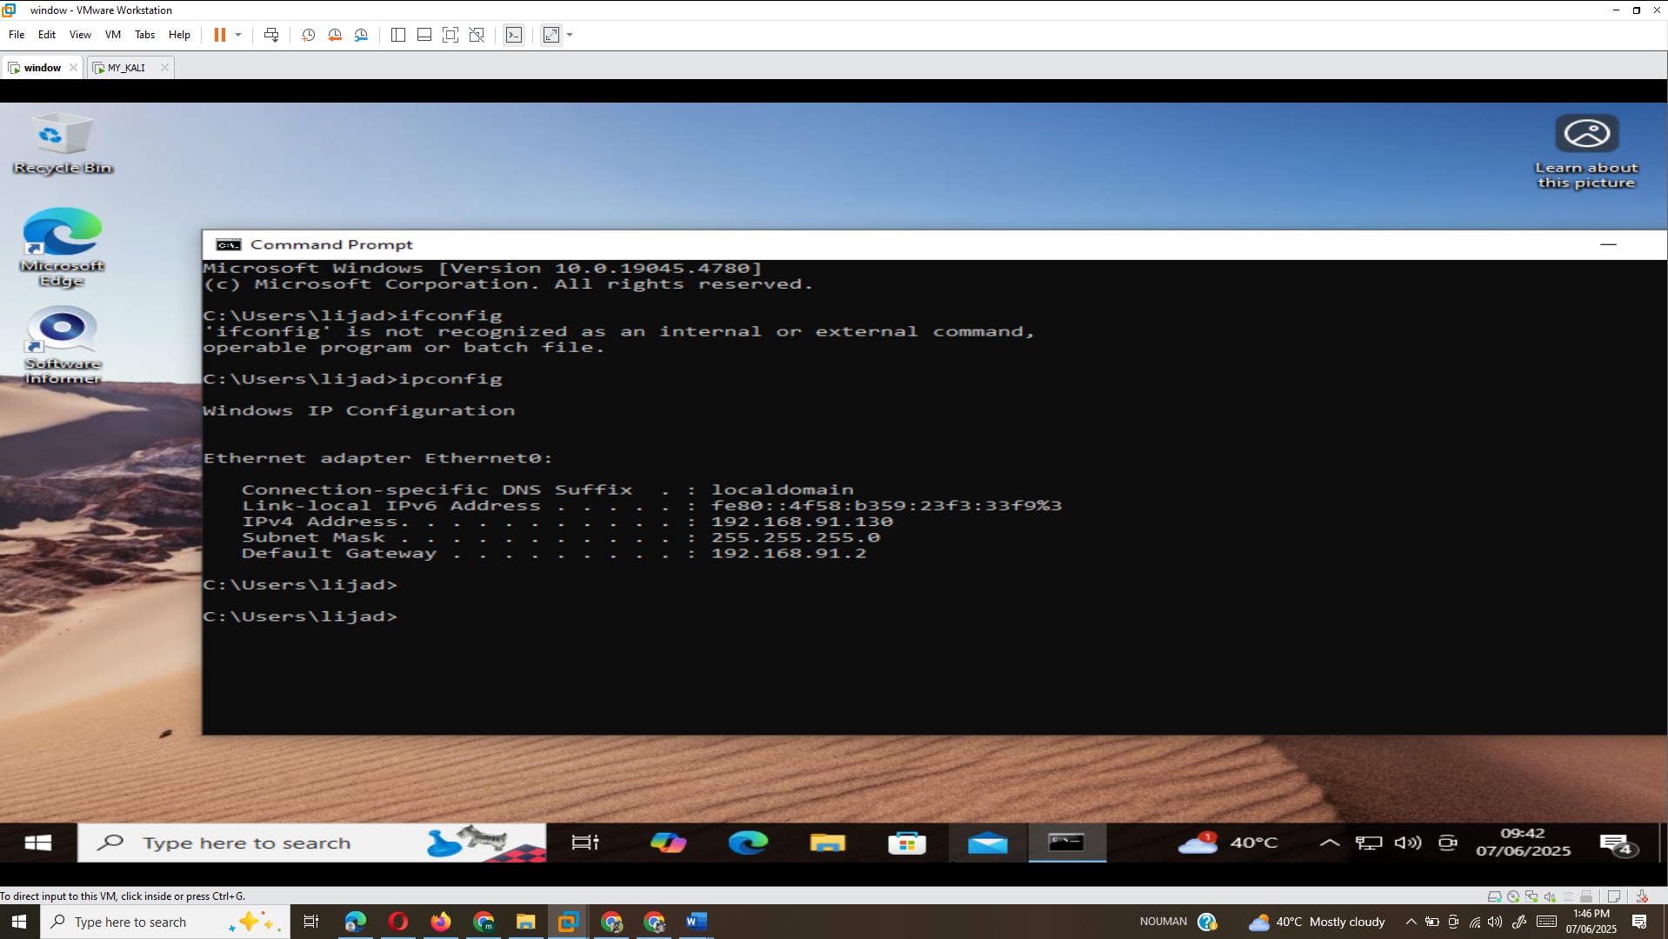

Step 17:  
Answer: 192.168.91.130

## Step 18:

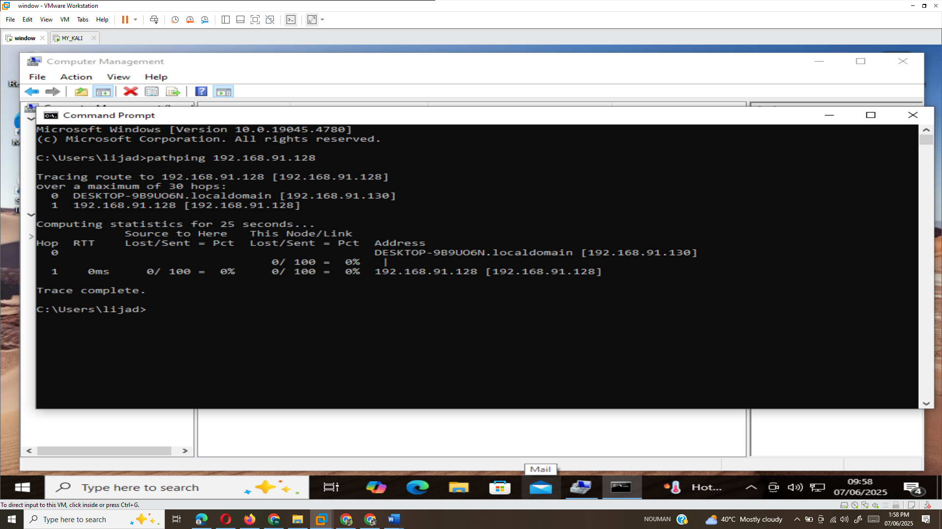

Step 19:  
 Approximate round trip times in milli-seconds:  
Answer: e.g., 0% packet loss

# Task B: Use Nmap to Discover Hosts

Switch back to Kali.

## Step 1–2:

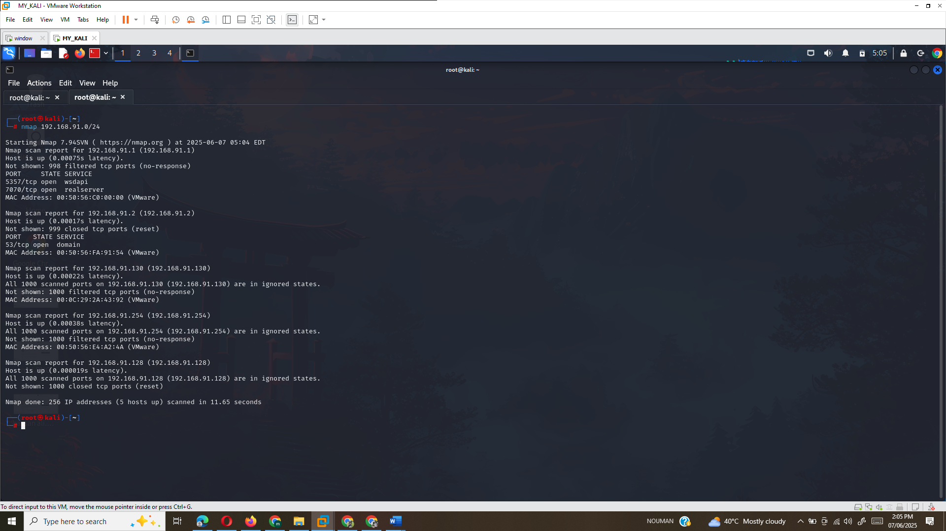

## **Step 3:** Fast SYN Scan

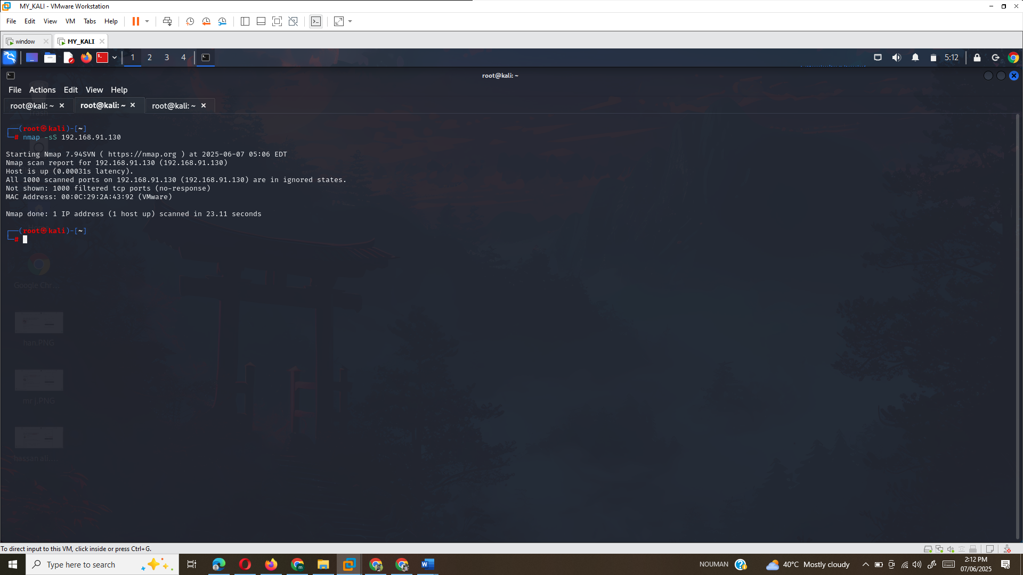

## **Step 4:** OS and service detection

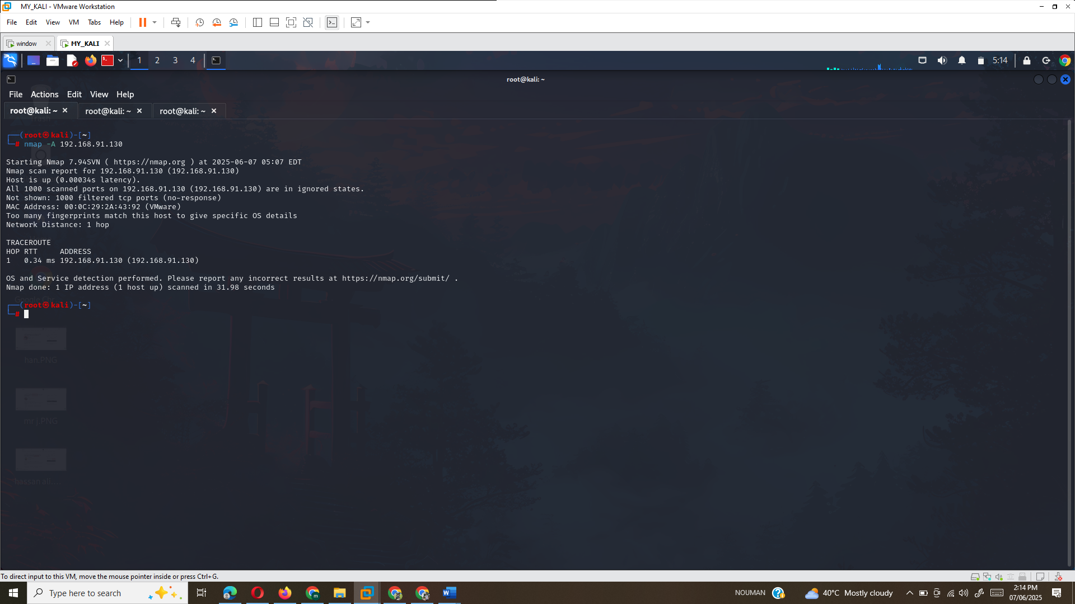

The **operating system** running on the host is **VMware**. The scan did not provide a clear match for an exact OS version but gave an indication that the host is running on a VMware virtual machine.

## **Step 5:** Scan port range 20–200

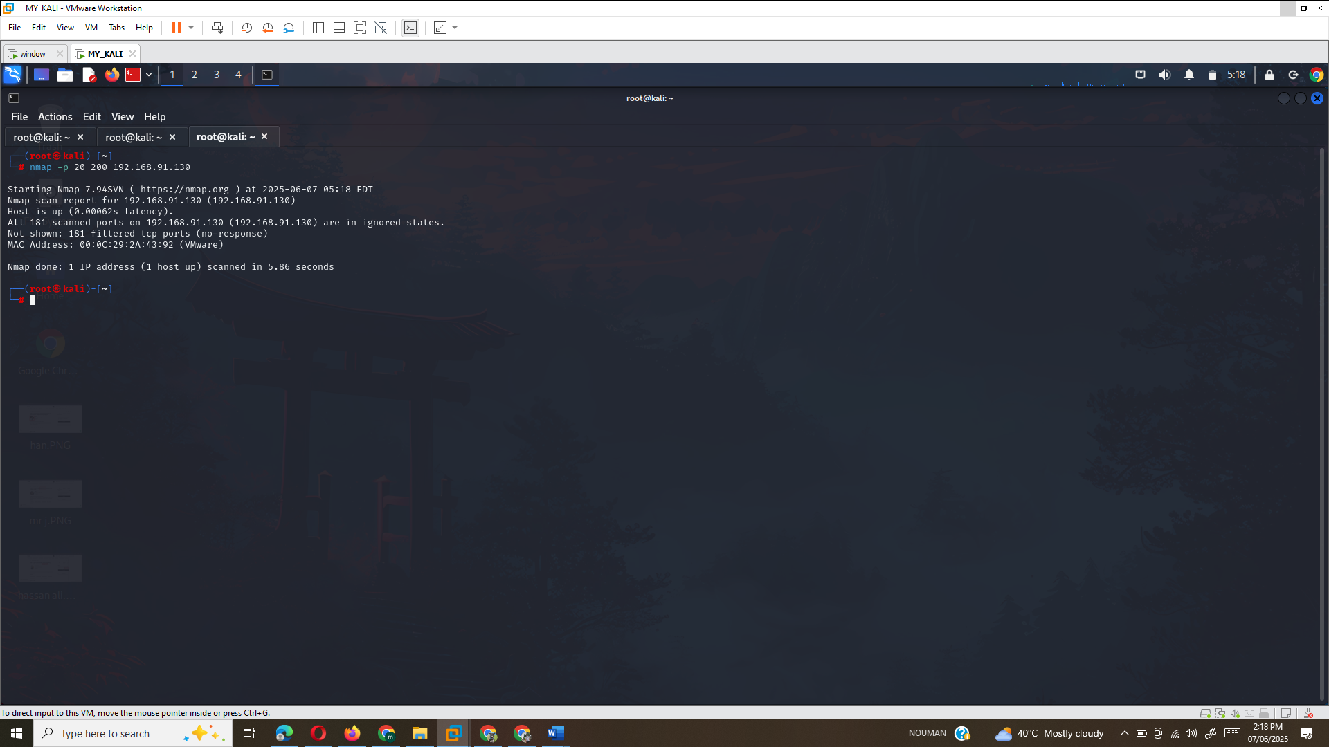

## **Step 6:** Scan top 20 ports

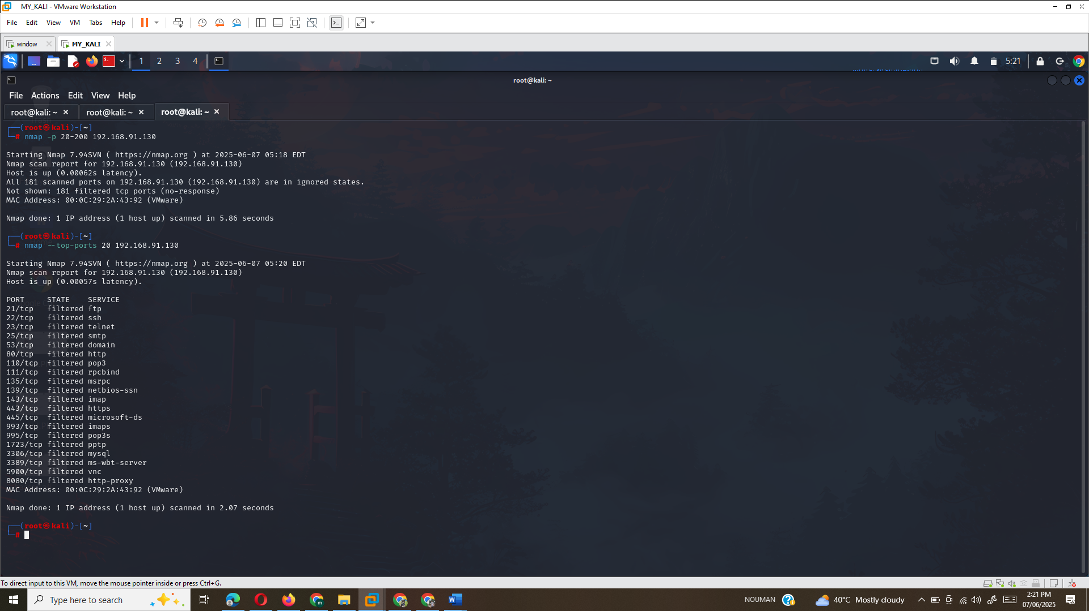

## **Step 7:** Host discovery (up/down)

